
(THE DATA CLOUD PLATFORM)
Transforming Your Data Strategy
Field | Details
Document Title | Snowflake Data Cloud Platform - Sales Proposal
Prepared For | [CLIENT COMPANY NAME]
Prepared By | Genufy TechWorks
Date
Version | 1.0
Classification | CONFIDENTIAL

Section No. | Section Title | Page No
1 | Executive Overview
1.1 | What is Snowflake?
2 | History of Snowflake
2.1 | Timeline & Evolution
2.2 | Reasons for Snowflake's Market Boom
3 | Core Architecture & Capabilities
3.1 | Key Drivers of Snowflake Adoption
4 | Business Value Proposition
4.1 | Before vs After Snowflake
4.2 | Why Snowflake Dominated the Market
5 | Snowflake Cost Structure
5.2 | Compute Costs by Edition
6 | Advantages & Disadvantages
7 | Integration & ETL
7.1 | Why ETL is Essential
7.2 | Informatica Integration with Snowflake
8 | Real-World Use Cases
9 | Industry Solutions
10 | Competitive Analysis
11 | Future Roadmap (2025-2027)
12 | Proof of Concept (POC) Plan
13 | Snowflake Capability Document
14 | Functional Document
15 | Contact Information

Snowflake and Its Advantages in the Cloud Data Warehousing Market
1. Executive Overview
1.1 What is Snowflake?
Snowflake is a cloud data warehouse that runs completely on the cloud (AWS, Azure, or Google Cloud).
You do NOT manage servers, storage, or patching – everything is automatic.
It stores data and runs queries separately (Storage ≠ Compute), so you only pay for what you actually use. Snowflake is commonly used as a Data Warehouse + Data Lake + Data Sharing platform in one place. Think of it as “Netflix for data” – unlimited storage, pay only when you watch (run queries).
Data Warehouse: Snowflake lets users run fast SQL analytics by separating storage and compute, so performance can scale easily when needed.
Data Lake: Snowflake allows users to store raw and semi-structured data and analyse it later without defining schemas in advance.
Data Sharing Platform: Snowflake makes it easy to securely share live data with other accounts without copying or moving the data.
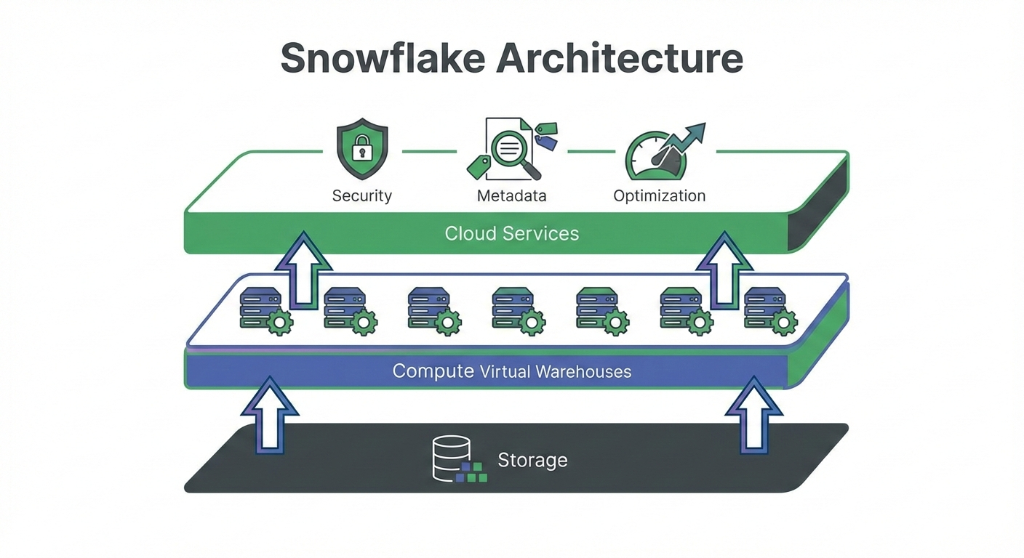

2.History of Snowflake + Reasons for its boom
2.1 Timeline & Evolution
- 2012: Snowflake founded (started with cloud-first data warehouse idea).
- 2014–2015: Early product launch and adoption phase (cloud DW category starts growing).
- 2020: Snowflake IPO brought huge market visibility.
- 2021–2025: Expanded beyond warehouse: Snowpark, data sharing, governance, and AI features (Cortex).
2.2 Reasons for Snowflake's Market Boom
- The old world: Companies ran Oracle, Teradata, or SQL Server data warehouses on-premises. Adding capacity meant purchasing servers, waiting for delivery, installation, configuration—often a 6 - 12 Month project.
- Snowflake: Capacity available in seconds. Need 10x compute power for quarter-end? Click a button. Done in 60 seconds.
Reason | Explanation
Cloud shift | Companies moved from on-premise to cloud
Big Data Growth | Data volumes exploded globally
Cost-Effective | Pay-per-use model saved money
Zero Maintenance | IT teams loved the simplicity
Easy Data Sharing | Enabled data marketplaces
SECTION 3: Core Architecture & Capabilities
3.1 Key Drivers of Snowflake Adoption:
- Snowflake is the only platform that delivers unlimited performance and infinite flexibility at dramatically lower cost with literally no infrastructure to manage
S.no | Driver | Description
1 | Separate Storage &Compute | Pay only for what you use separately
2 | Auto-Scaling | Handles traffic spikes automatically
3 | Zero Maintenance | No tuning, indexing, or vacuuming
4 | Multi-Cloud Support | Works on AWS + Azure + GCP
5 | Data Sharing | Share live data without copying
6 | Time Travel | Recover deleted data up to 90 days
7 | Concurrency Handling | Multiple users = No slowdown
Section 4: Business Value Proposition
4.1Business Value in Simple Terms
Before Snowflake:
- "Our monthly sales report takes 6 hours to generate"
- "We can't combine marketing data with sales data easily"
- "Our data warehouse crashes during quarter-end reporting"
- "IT says a new analytics project will take 6 months to set up"
After Snowflake:
- "Reports that took 6 hours now complete in 8 minutes"
- "Marketing, sales, and finance data live in one place"
- "500 users ran reports simultaneously during quarter-end—no crashes"
- "New analytics projects spin up in days, not months"
4.2 Why Snowflake Dominated Market:
Snowflake dominated the market by eliminating traditional data warehouse limitations through a fully cloud-native, managed architecture. It enables instant scalability, zero infrastructure maintenance, and a true pay-per-use cost model.
Traditional Challenges | Snowflake Solution
Hardware procurement delays | Instant provisioning
Complex capacity planning | Elastic scaling
High upfront costs | Pay-per-use model
Manual maintenance overhead | Zero administration

SECTION 5: Snowflake Cost Structure:
Storage Cost: ~₹1,900/TB per month Compute is billed per credit based on edition and warehouse size; storage is billed per TB per month, allowing you to scale compute and storage independently.
Snowflake follows a transparent, usage-based cost model where storage and compute are billed independently. Clients pay only for what they use, enabling precise cost control without upfront infrastructure investment.
Edition | Per Credit (USD) | Per Credit (INR) | Use Case
Standard | $2.00 | ₹166 | Small teams, basic needs
Enterprise | $3.00 | ₹249 | Large organizations
Business Critical | $4.00 | ₹332 | Healthcare, Finance (sensitive data)
VPS (Virtual Private) | $5.50+ | ₹456+ | Government, highly regulated industries

SECTION 6: Advantages & Disadvantages of Snowflake
Advantages:
✔Pay only for actual usage (big savings)
✔ Loads terabytes in minutes
✔ Unlimited users can query same data at same time (no slowness)
✔ Zero server management
✔ Share live data with partners securely (Data Share feature)
✔ Supports semi-structured data (JSON, Parquet) easily
Disadvantages:
✘Can become costly if queries are not controlled
✘ You cannot see inside the server (black box)
✘ Need internet always
SECTION 7 Integration & ETL:
7.1Why ETL is Essential for Snowflake:
- ETL is essential in Snowflake to transform raw, multi-source data into trusted, analytics-ready information.
- It ensures data quality, automation, and governance while enabling faster, reliable business insights.

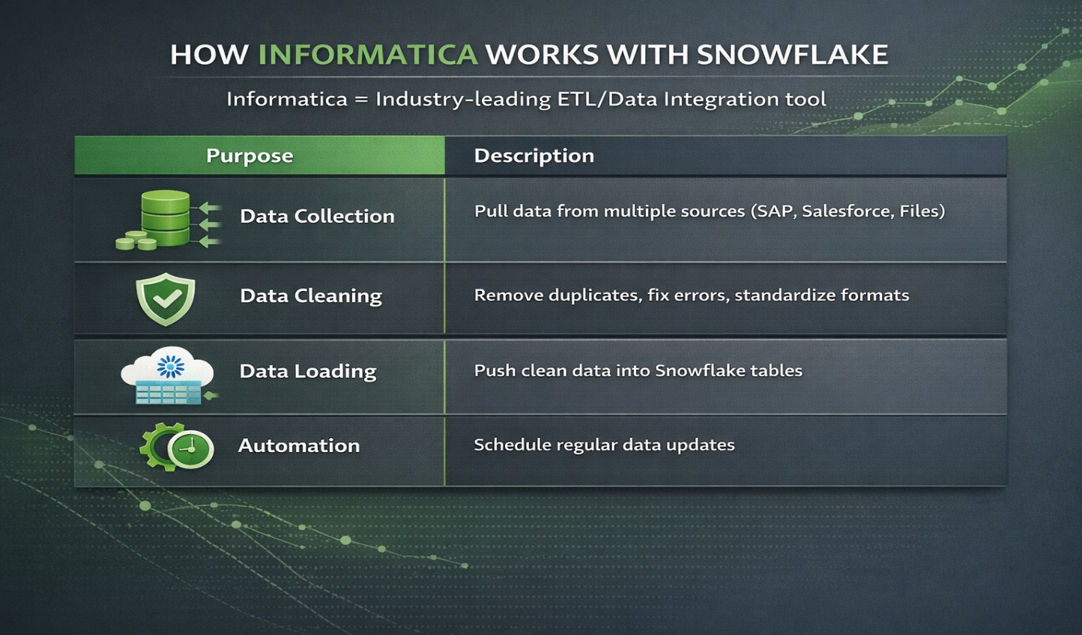

7.2 HOW INFORMATICA WORKS WITH SNOWFLAKE:
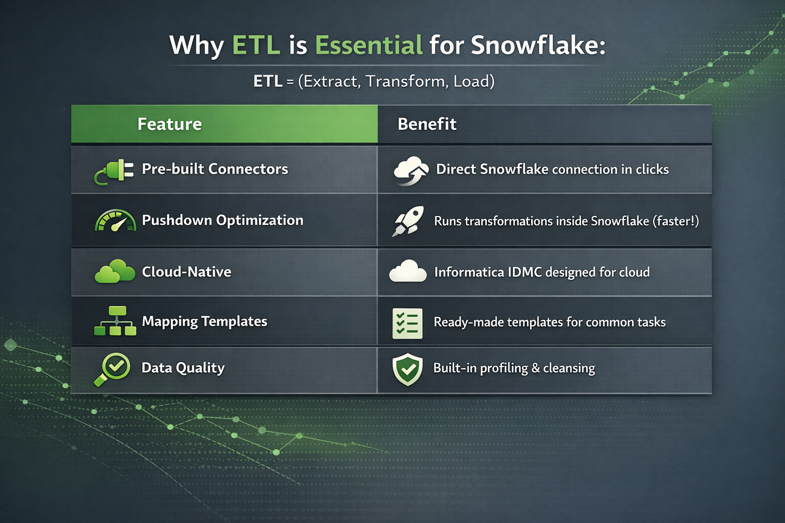
Informatica + Snowflake Integration Benefits:
Capability | Benefit
Pushdown Optimization | Execute transformations directly in Snowflake
Pre-built Connectors | Rapid source system connectivity
Visual Designer | Low-code/no-code development
Enterprise Governance | Centralized metadata management

SECTION 8: Real-time use cases with real-world examples
8.1 Use Case A: Retail Sales Analytics (near real-time dashboards)
- Goal: Track hourly sales, inventory, and returns.
- Flow: POS data → ETL tool/stream → Snowflake → BI dashboard.
- Outcome: Faster decisions on restocking and discounts.
Example: A multi-store retailer loads daily + streaming sales data to Snowflake and uses separate warehouses for:
- ETL load (small warehouse)
- BI queries (medium warehouse)
So BI users don’t slow down data loading.
8.2 Use Case B: Banking/FinTech Risk Monitoring
- Goal: Detect unusual transactions and monitor risk KPIs.
- Flow: Transaction logs → staged in Snowflake → curated tables → risk reports.
- Outcome: Better reporting speed and governance.
8.3 Use Case C: Healthcare Claims and Patient Analytics
- Goal: Combine claims + appointment + lab data for reporting.
- Flow: Multiple source systems → Informatica → Snowflake → analytics.
- Outcome: A single “source of truth” dataset with access control.
8.4 Use Case D: SaaS Product Analytics
- Goal: Analyse user events (clicks, sessions, feature adoption).
- Flow: App events → data pipeline → Snowflake → metrics tables.
Outcome: Product team measures adoption and churn drivers quickly.
SECTION 9: Industry Solutions
Snowflake empowers industries to turn complex data into actionable intelligence at scale. From real-time analytics to compliance-driven reporting, it accelerates innovation across every sector.
Industry | Primary Use Cases | Key Benefits
Retail | Dynamic pricing + Inventory analytics | Real-time demand sensing
Banking | Fraud detection + Regulatory reporting | Compliance automation
Healthcare | Patient 360 + Clinical trials | Unified patient view
Manufacturing | IoT sensor data + Predictive maintenance | Reduced downtime
Media & Entertainment | Content analytics + Audience insights | Personalized experiences
Telecommunications | Network optimization + Customer churn | Proactive retention

SECTION 10: Competitive Analysis:
Criteria | Snowflake | Amazon Redshift | Google BigQuery | Databricks Lakehouse
Raw Query Speed (TPC-DS 30TB) | 1st place | 4th place | 2nd place | 3rd place
Concurrent Users (1000+ users) | Unlimited – zero slowdown | Starts queuing after ~100 | Good up to ~500 | Good up to ~800
Real-time/Near real-time | Snow pipe + Streams + Tasks (<2 min standard) | RA3 + Streaming Ingestion (5–10 min) | Big Query Streaming (5–15 min) | Delta Live Tables (true sub-second)
Ease of Operations | Literally zero admin | Weekly vacuum/analyze needed | Very low | Medium (Spark tuning still exists)
Multi-Cloud (native) | AWS + Azure + GCP same account | AWS only | GCP only | All clouds but account per cloud
Live Data Sharing | Native, zero-copy, zero cost | Very difficult | Possible via BQ Omni (expensive) | Possible via Delta Sharing
Cost at Scale (real client data) | ₹9–14 Cr/year for 200 TB + heavy use | ₹22–35 Cr/year | ₹15–25 Cr/year | ₹18–30 Cr/year
Python / ML in the platform | Snowpark (Python/Java/Scala) – runs inside Snowflake | Redshift ML + SageMaker | Big Query ML | Native Spark + MLflow

SECTION 11: Future of Snowflake (2025–2027 Roadmap)
Already live or coming soon:
→ Iceberg tables – use same data with Spark also
→ Built-in Python, Java, Scala inside Snowflake (Snowpark)
→ AI features – ask questions in English & get charts (Cortex Analyst)
→ Snowflake Native Apps – install apps like Five Tran inside Snowflake
→ More cost control – auto-stop idle warehouses in seconds
By 2027 Snowflake wants to become the “single platform for all data + AI” work.

SECTION 12: Proof of Concept (POC)Plan
12.1 Ready-to-Use POC Idea (You can run in 2 days)
Title: "Migrate 30 days of Amazon reviews data (public dataset) and show 10x faster dashboard"
- Load 50GB Amazon reviews JSON (public S3 bucket)
- Query with 5 analysts at same time (create 5 warehouses)
- Show Zero-copy clone for dev/test
- Share one dashboard live with customer (no ETL)
- Show cost report (should be <$50)
POC (Proof of Concept) Plan
If you want to prove Snowflake works for your company, run this 2-week test:
- Ingest: Load 1 Terabyte of your historical data.
- Query: Run your 5 slowest reports on Snowflake. Compare the time against your current system.
- Concurrency: Have 10 users run reports at the exact same time.
- Clone: Create a test environment using "Zero-copy clone."

SECTION 13: Snowflake Capability Document
- This capability document highlights Snowflake’s core features that deliver scalability, speed, security, and simplicity across analytics and data science.
- It demonstrates how Snowflake solves real business problems through practical, production-proven capabilities.
Capability | Use Case | Real Example
Separate Storage & Compute | Run 100 reports at month-end without slowing anyone | Finance team uses XL warehouse for heavy reports;  Marketing uses XS for dashboards – no resource  conflicts
Zero-Copy Cloning | Create test environment instantly | Clone 10TB production in 3 seconds; developers test  without touching real data
Time Travel | Recover from human error | Someone ran "DELETE FROM sales" → Recover data  from 2 hours ago with one command
Secure Data Sharing | Share live data with partners/customers | Share real-time inventory with 200 retail partners;  they query directly – no files, no delays
Snowpark | Data scientists work where data lives | Run Pandas, Scikit-learn directly inside Snowflake –  no data movement required
Snow pipe Auto-Ingest | Real-time analytics | Files land in S3 → automatically loaded in <2 minutes;  used by companies like Zomato/Swiggy for live order  tracking
Marketplace | Get third-party data instantly | Add Nielsen consumer data or Weather data with  one click

SECTION 14: Functional Document (For Product Owner / Business Analyst)
Business Need | Traditional Way | Snowflake Way | Benefit to Business
Fast month-end reporting | Wait 8–10 hours, servers crash | Reports ready in minutes | Close books faster
Share data with partners | Email Excel/CSV every week | Partners query live data themselves | Real-time, no manual work
Create test environment | Wait 3–4 weeks for IT | Click one button → ready in seconds | Launch products faster
Control cloud cost | Get surprise bill every month | See exact cost per team/report | Save 40–60% on average
Protect sensitive data | Complex masking projects | Apply masking policies in minutes | Pass audits easily
Work with JSON/IoT data | Need expensive ETL tools | Store & query JSON natively | Save millions in ETL licensing

